**Predicting And Analyzing Urban Water Quality Using IBM Watson Machine Learning Service**

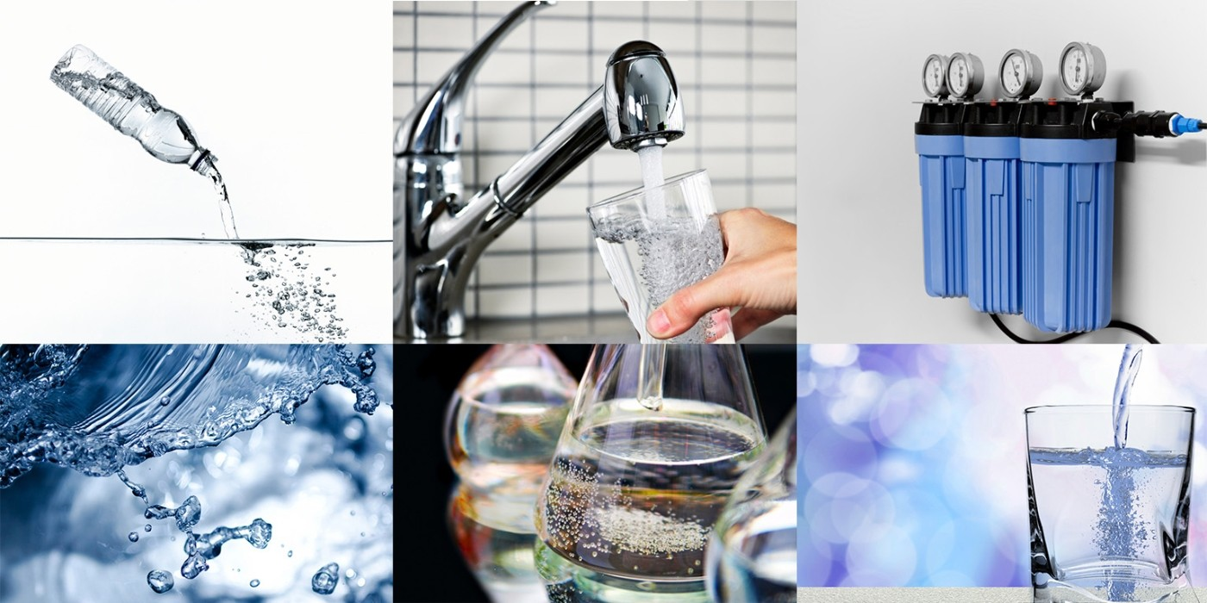

*ARUTLA SREEVANI*

INDEx

# Introduction

# Some of the Factors

# Block Diagram

# Flow Chart

# Result

# Advantages & Disadvantages

# Applications

# Conclusion

**INTRODUCTION TO PROJECT**

**Water quality** refers to the chemical, physical, and biological Characteristics of water based on the standards of its usage. Water is considered as a vital resource that affects various aspects of human health and lives. The quality of water is a major concern for people living in urban areas. Quality of water serves as a powerful environmental determinant and a foundation for the prevention and control of waterborne diseases. However predicting the urban water quality is a challenging task since the water quality varies in urban spaces non-linearly and depends on multiple factors, such as meteorology, water usage patterns, and land uses, so this project aims at building a Machine Learning (ML) model by considering all water quality standard indicators.

predicting the urban water quality is a challenging task since the water quality varies in urban spaces non-linearly and depends on multiple factors , such as meteorology , water usage patterns, and land uses, so this project aims at building a Machine Learning(ML) model by considering all water quality standard indicators.

We have designed a model for prediction of urban water quality for this prediction we have considered various water quality from various states.

Some of the factors:

>>> CONDUCTIVITY

>>> NITRATENAN N+ NITRITENANN

>>> FECAL COLIFORM

>>> B.O.D(biochemical oxygen demand)

>>> D.O(dissolved oxygen)

>>> PH

Block Diagram :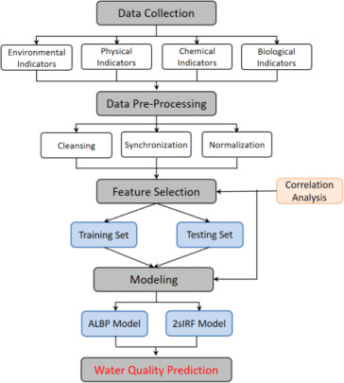

Flow Chart :

Data Collection.

Collect the dataset or Create the dataset

Data Preprocessing.

Import the Libraries

Importing the dataset

Checking for Null Values

Data Visualization

Taking care of Missing Data

Label Encoding

One Hot encoding

Feature Scaling

Splitting Data into train and Test

Model Building

Training and Testing the model

Evaluation of Model

Application Building

Create an HTML file

Build a Python Code

Result :

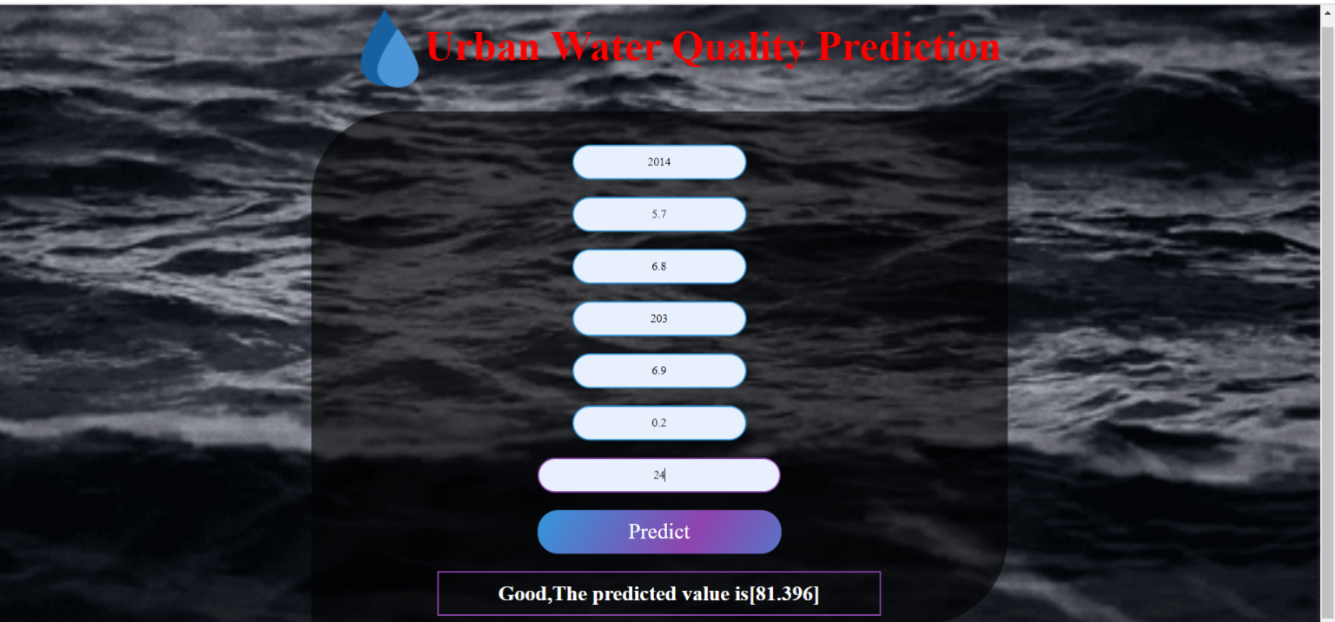

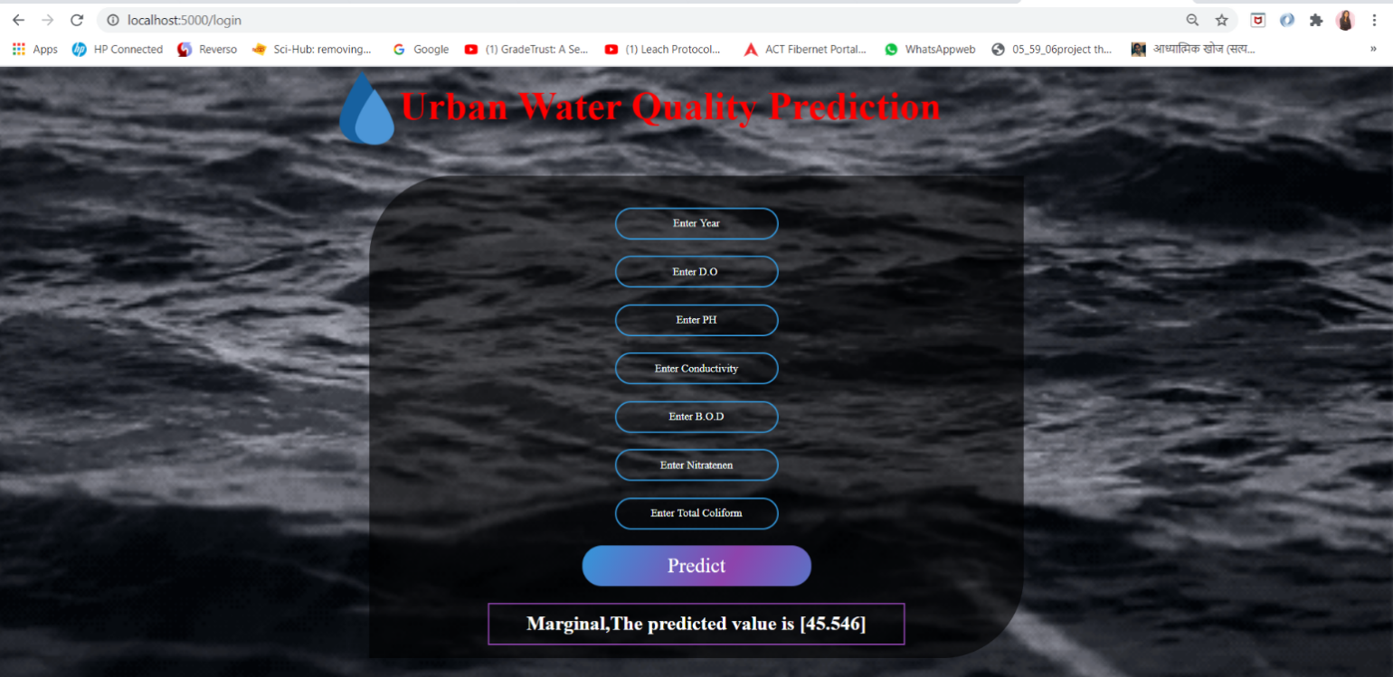

ADVANTAGES AND DISADVANTAGES :

>>> Water quality specialists use models for many purposes: Assessing water quality conditions and causes of impairment. Predicting how surface waters will respond to changes in their watersheds and the environment (e.g., future growth, climate change).

>>> The economic performance of a waterflood or a water disposal project can be significantly affected by suspended solids in the injection water. Here are methods and a theory that can be used to interpret water quality data obtained with membrane filters or cores and to predict.

Applications :

Prediction of water quality is a critical issue because of its significant impact on human and ecosystem health. This research aims to predict water quality index (WQI) for the free surface wetland using three soft computing techniques namely, adaptive neuro-fuzzy system (ANFIS), artificial neural networks (ANNs), and group method of data handling (GMDH).

Conclusion :

The findings of this study could be used as an effective reference for policy makers in the field of water resource management. Decreasing variables, reduction of running time, and high speed of these approaches are the most important reasons to employ them in any aquatic environment worldwide.

# By the end of this project:

>>> we’ll be able to understand

>>> Regression and Classification Problems

>>> To grab insights from data through visualization.

>>> Applying different algorithms according

>>> Evaluation metrics

>>> How to build a web application using the Flask framework.